Lab 02.5 – Docker Compose

1. Tạo thư mục mới
mkdir lab5-compose
cd lab5-compose
2. Tạo file docker-compose.yml
nano Docker-compose.yml:
version: '2'

services:
db:
image: mysql:5.7
container_name: mysql_db
restart: always
volumes:
- ./data:/var/lib/mysql
environment:
MYSQL_ROOT_PASSWORD: wordpress
MYSQL_DATABASE: wordpress
MYSQL_USER: wordpress
MYSQL_PASSWORD: wordpress

wordpress:
image: wordpress:latest
container_name: wordpress_web
depends_on:
- db
ports:
- "8000:80"
restart: always
environment:
WORDPRESS_DB_HOST: db:3306
WORDPRESS_DB_USER: wordpress
WORDPRESS_DB_PASSWORD: wordpress
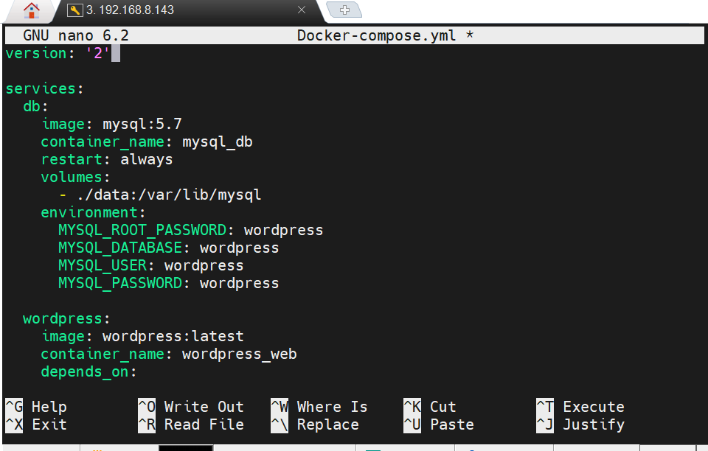
3. Tải docker-compose
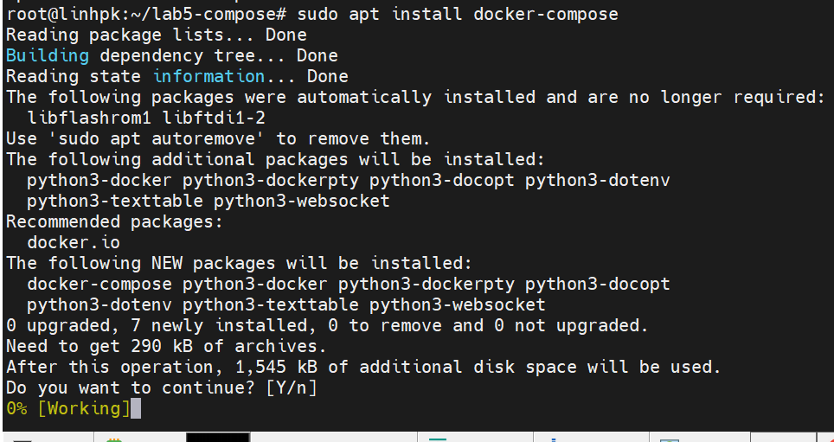

4. Chạy lab
docker-compose up -d
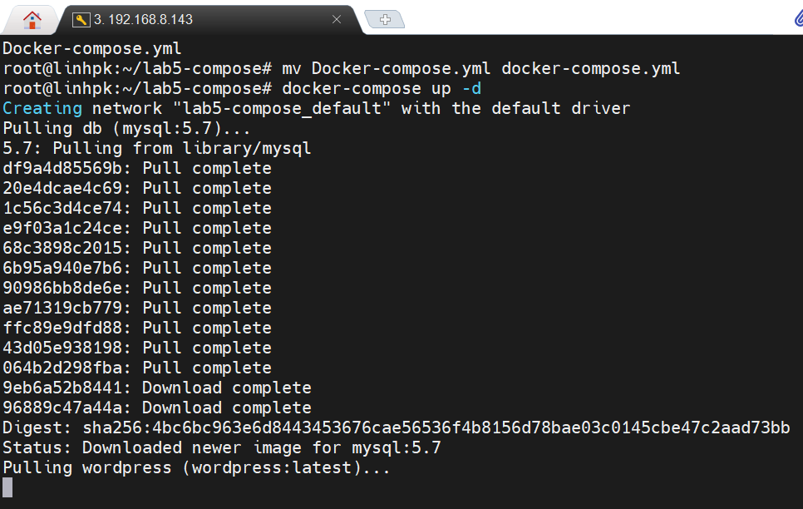
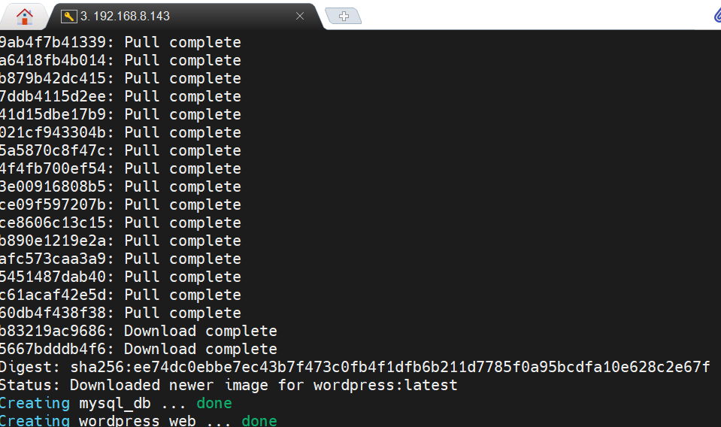

5.Kiểm tra container
docker-compose ps
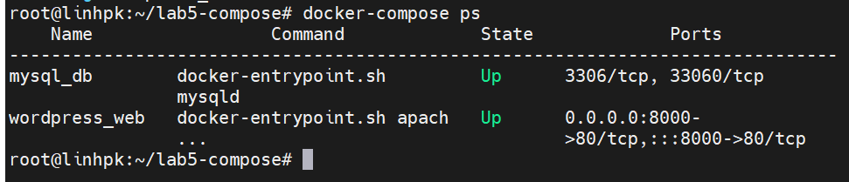

6. Truy cập: http://192.168.8.143:8000 để vào Wordpress
